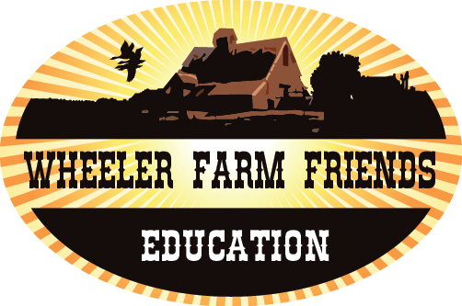

Purpose
To learn about the water cycle and its impact on irrigation.

Time: 60-minutes

Level: This lesson can be used and modified for students in grades 3-6

Materials
- Styrofoam or paper cups (1 per student) filled to within an inch of the top with soil
- Markers
- Six eyedroppers
- Extra cups
- Bean seeds (2 per student)
- Watering can
- Clock, watch, or stopwatch

Standards
- Utah Science Core Standard 1, Objective 2, Indicator e: Describe how the water cycle relates to the water supply in your community.

- Common Core Writing Anchor Standard 2: Write informative/explanatory texts to examine and convey complex ideas and information clearly and accurately through the effective selection, organization, and analysis of content.

Essential Questions
- How does irrigation affect plants?
- How does the water cycle impact irrigation?

Wheeler Farm Friends - Education

Irrigation
for older grades
Science and Language Arts

This lesson comes from a lesson by Rich Engel produced for the U.S. Bureau of Reclamation: http://www.usbr.gov/mp/watershare/resources/lessonplans/aw-elementary.html

Background
In 1940 the average farmer in the United States could produce enough food for 19 people. Today, an American farmer can produce enough food to feed 129 people -- 101 in the United States and 28 abroad. Technological advances have increased the productivity of farmers, particularly by improving their ability to provide water to their crops through irrigation. Irrigation is defined as the managed application of water to soil for the purpose of increasing crop production. Irrigated agriculture has helped American farmers produce the most abundant and diverse supply of food, fiber and foliage products in the world. Irrigation plays an especially important role in the Western United States where growing seasons are longer but there is not enough rainfall to supply an optimum amount of water to commercial crops. California alone produces over 250 agricultural commodities, most of which could not be grown there without irrigation.
The method of irrigation can determine whether a crop can produce enough food or fiber to be economically feasible. Water must be applied both at the right time and in the right amounts to be useful. This activity will provide students with an understanding of proper water utilization.
Activity Procedures
- Divide the students into five groups, A through E.
- Give each student a cup filled with soil and two bean seeds.
- Have the students make a hole 3/4" deep in the soil and plant the seeds.
- Have the students write their names and group number on their individual cups.
- Assign each group a place for their cups indoors, where the plants can get plenty of light.

Group A: Dryland Farming
The first group represents farmers who do not use any irrigation system. The only time these students can water their plants is when it rains outside. If it is pouring rain, they have to flood their cups. If it rains lightly, only a few drops are allowed. If it doesn't rain, tough.

Group B: Micro-irrigation
This group will use eyedroppers to administer a few drops of water to their crops at frequent intervals throughout every school day.

Group C: Gravity flow Irrigation
Members of this group will each take one cup of water and pour it directly into the planted cup until the water level reaches the rim. The students will observe the plants and only water when the soil is dry.

Group D: Sprinkler Irrigation
These students will use a watering can with a flow diffuser to water their plants 2 times per week, applying just enough to wet the soil without flooding it.

www.wheelerfarmfriends.org/education

Wheeler Farm Friends - Education

Follow up: Preferably, the primary difference between these groups will be the amount, method and frequency of water application. Students likely will see a difference in growth and health of the plants as a result of these variations. The micro irrigation students who undertake their assignment conscientiously should see the best results. As this is simply a familiarization exercise, not a controlled experiment, other variables will affect successful germination and growth. In a follow up discussion students can compare the growing conditions for each group. (And some people have a green thumb, some don't.)
Conclusions: There are many ways to water crops. Farmers select a method that applies water efficiently with productive results. When all other factors are held equal, small steady doses of water provide the best results, while requiring the most attention.

Assessment: (added by Wheeler Farm Friends)
Students are assessed on their completion of the activity and recording their observations.

www.wheelerfarmfriends.org/education

Name: _____________________________________________________Date: _________________________________

Plant Irrigation Record Book

I am in Group __________. I water my plant
when: ___________________________________________________________
how: ___________________________________________________________
________________________________________________________________
________________________________________________________________

In the chart below, draw and describe your observations about irrigation and your plant:

Day 1 | Day 2 | Day 3 | Day 4 | Day 5
Drawing: | Drawing: | Drawing: | Drawing: | Drawing:
Description: | Description: | Description: | Description: | Description:

How did your method of irrigation affect your plant? If you were a farmer, would you choose another method? __________________________________________________
_______________________________________________________________________
_______________________________________________________________________
_______________________________________________________________________
_______________________________________________________________________

Wheeler Farm Friends – Education www.wheelerfarmfriends.org/education

