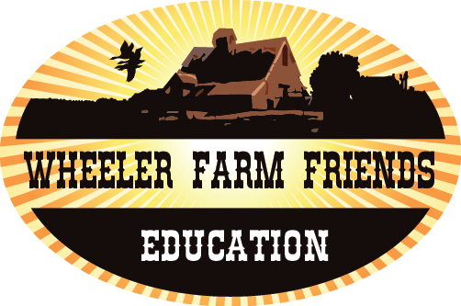

Purpose
To learn about how the water cycle influenced farms and families like the Wheelers in the past and how it continues to impact us today.

Time: 60-minutes
Level: This lesson can be used and modified for students in grades K-4
Materials
- 2 Pitchers full of water
- Small cups (1 for each student)
- Timer

Standards
- Utah Science Core 1st grade standard 2, objective 1, indicator c: Gather evidence about the uses of rocks, soil, and water.
- Common Core Language Arts
Writing Anchor Standard 2: Write informative/explanatory texts to examine and convey complex ideas and information clearly and accurately through the effective selection, organization, and analysis of content.

Essential Questions
- Why does a farmer need to irrigate?

Wheeler Farm Friends - Education

Irrigation
for younger grades
Science and Language Arts

Background
One of the most important natural resources that covers the earth’s surface is water. All living things depend on water for survival. As the world population continues to grow, more and more people, plants, animals, and other living creatures need water to live. Water is a renewable resource used over and over through evaporation, transpiration, and precipitation. The water that is on earth now is the same water that has always been here. No “new” water is being made. The movement of water in and around the earth is called the water cycle. The water cycle is a continuous cycle. Rain or snow falls on oceans and land as precipitation. The soil will soak up some of the water. Plants will take up some of this water through their roots and some water will move down through the soil and become groundwater. Some of the water from the rain and snow will run off the land into streams, marshes, lakes, and oceans. The water that remains on the earth’s surface is called surface water. The surface water will return to the atmosphere through evaporation. Then water vapor may form clouds that cause precipitation —rain or snow — to occur again. The precipitation will return to the surface of the earth and the cycle will continue. Water is extremely important for crop production because crops (plants) need water to grow. A good crop of corn or soybeans needs at least 20 inches of water a year. Yet, almost every year, the corn and soybeans’ water is limited to some degree by drought. Drought is when there is a lack of water. Some years the summer rainfall is below normal and some years there are varying amounts of rainfall throughout the season. Due to these situations, more and more farmers are installing irrigation systems to ensure that their crops receive an adequate amount of water. Irrigation is watering land with artificial methods, or man-made watering. Water is taken from lakes, rivers, streams, and wells, transported to croplands, and used to water the crops. Irrigation is used in areas that go without rainfall for a long time. Places such as the Southwest U.S., Egypt, and Italy use irrigation during dry periods or all year. Utah farmers have used irrigation methods to water their crops since the first pioneers settled the Salt Lake Valley (Reproduced with the permission of Utah Agriculture in the Classroom, Utah State University, [online] www.agclassroom.org/ut.)

In Sunset of the Farmer, Beverly Wheeler Mastrim recalls making ditches at Wheeler farm so that water could nourish the rows of corn: “It seemed almost a trick of wizardly to see the wilting tomatoes, corn and other plants, drooping under that long ago hot summer sun, quickly come to life and stand firm and erect again” (p. 68).

Activity Procedures

This lesson was adapted from a lesson by Rich Engel for the U.S Bureau of Reclamation (http://www.usbr.gov/mp/watershare/resources/lessonplans/aw-elementary.html)

The Wheelers grew corn on their farm to feed themselves and their animals. For this activity, the classroom becomes a cornfield, each student is a stalk of corn, and the teacher is the farmer. The stalks of corn need water to grow and produce corn. If any corn stalk does not get enough water, it will shrivel and die.

Pass out 1 cup to each student/corn stalk. Tell the students that their cup needs to be at least half full in order to live. The teacher/farmer will be timed to see how long it takes to get water to all the corn. However, all of the corn stalks need water at the same time. If water does not get to the corn quickly enough, it will shrivel and die. Instruct students to pretend they are reporting their condition as a corn stalk over time.

Start the timer and begin to fill each student's cup half full. When every cup is at least half full, stop the timer. Discuss with students how long that it took and have students discuss their condition as corn stalks and the damaged suffered by the corn that was last to be watered. Ask the students/corn for ideas about how to get all the cups filled in less time.
www.wheelerfarmfriends.org/education

Wheeler Farm Friends - Education

Do the watering a second time. However, this time have someone help you get the water to the corn using two pitchers. Using a timer, measure how long it takes to get water to the corn. After, ask students:
- Did the corn do better with less waiting? Why?
- How could a farmer get water to his plants more quickly?

Discuss with students that the resources and energy a farmer puts into his plants helps them be healthier and useful.

Assessment:
Students are assessed in their participation in the activity and their description of why irrigation is important.

www.wheelerfarmfriends.org/education

Name: ____________________________________________ Date: _________________________________

Irrigation Illustration

Describe with words and illustrate with pictures the irrigation process and why it is important:

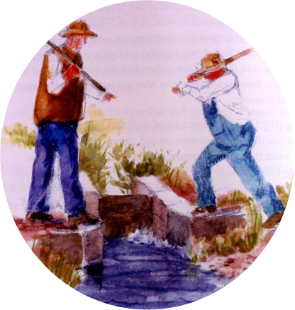
“Unresolved” by Beverly Wheeler Mastrim

Wheeler Farm Friends - Education www.wheelerfarmfriends.org/education

