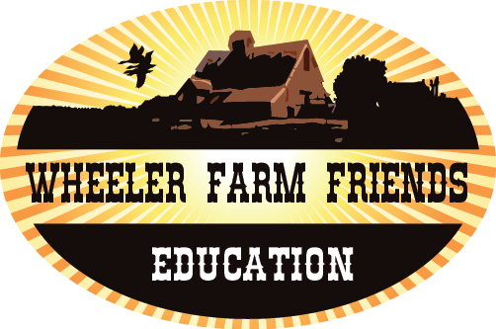
Time: 60-minutes
Level: Upper and Lower grade Elementary
Materials
☐ Worksheet from Edhelper.com
☐ virtual timeline found

Essential Questions
- What is the purpose of a timeline
- What is the difference between a primary and secondary source?
Core Standards
Compare and contrast the overall structure (e.g., chronology, comparison, cause/effect, problem/solution) of events, ideas, concepts, or information in two or more texts.
Resources:

www.edhelper.com

A Timeline

Background
Wheeler Farm was not always just the Wheelers. The way land was owned has changed over time due to major world events. The farm went from Squatters too ownership due to Utah becoming a state. When analyzing primary source documents it is important to look at the photograph carefully in order to determine the order in time. This is not an easy job for a historian and most of the time many sources are used to determine the significance and relevance to the farm. From oral histories of Beverly Wheeler Mastrim to old photographs.

Activity Procedures
Students will go home and tape or write down the history of their family. Talk about how oral histories are a primary source. They must do this before doing the indep. Activity. Tell them it is best to record the person and ask the person to share 5 or 6 artifacts and why they are important to the family history. Artifacts could be an old shoe, a picture, a handmade blanket etc.

Modeled Activity
- Show the virtual timeline and have students discuss what major events are exhibited in the photographs. For example the picture of Beverly and her husband shows that he is in a sailor outfit. Discuss WW II at this time and how that is shown in this picture.
- Discuss how primary sources are people, written journals, art from that specific event or time period. A secondary source is a biography or a source written after the fact.
Independent Activity
3.) Students will fill out the timeline according to the oldest event they know of in their family. They can also draw pictures of artifacts that explain their families history over time. If they want they can choose to bring in these artifacts when sharing their timeline with the class. Explain to the that timelines are necessary when discussing historical events because it helps us look for themes, patterns, and eras that change over time. Ethel said that her farm in Utah changed into neighborhoods and markets over night. One day she went to buy apples in milcreek and it was already turned into a building. She said she saw Utah Valley change over night. “It was not an evolution it was a revolution.” Her way of life as she new changed right before her eyes and farms disappeared right before her eyes.
Post Fieldtrip:
Can you make a timeline of the farm from artifacts that were shared with you at the farm. If so draw a picture of an artifact you saw at the farm and mail it into wheeler. The best timelines will be displayed at the farm!

